|  |  |
| --- | --- |
| **Name :-** | Aryan Dilipbhai Langhanoja |
| **Enroll No: -** | 92200133030 |

## Majority circuit using basic logic gates

* **Aim** :-

To construct a majority circuit application using basic logic gates. The users will be able to obtain simplified expressions from given k-maps and given combinational circuits. The users will be able to state the number of integrated circuits required for constructing a given function.

* 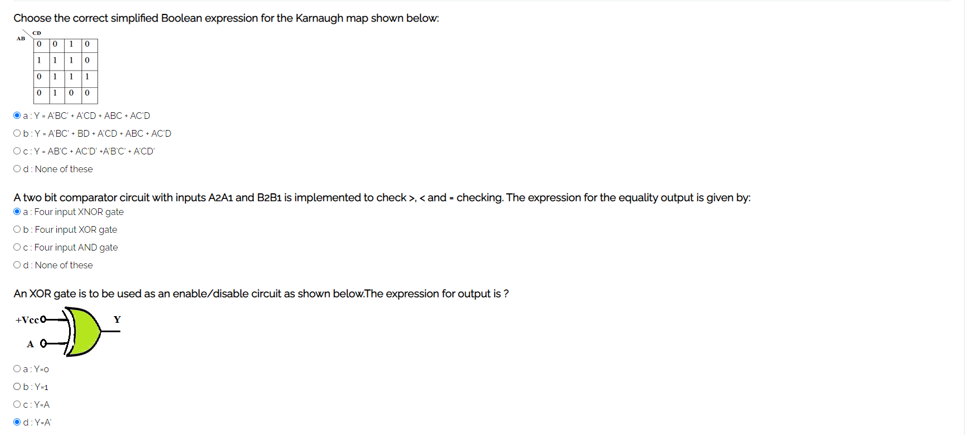**Pre-test :-**

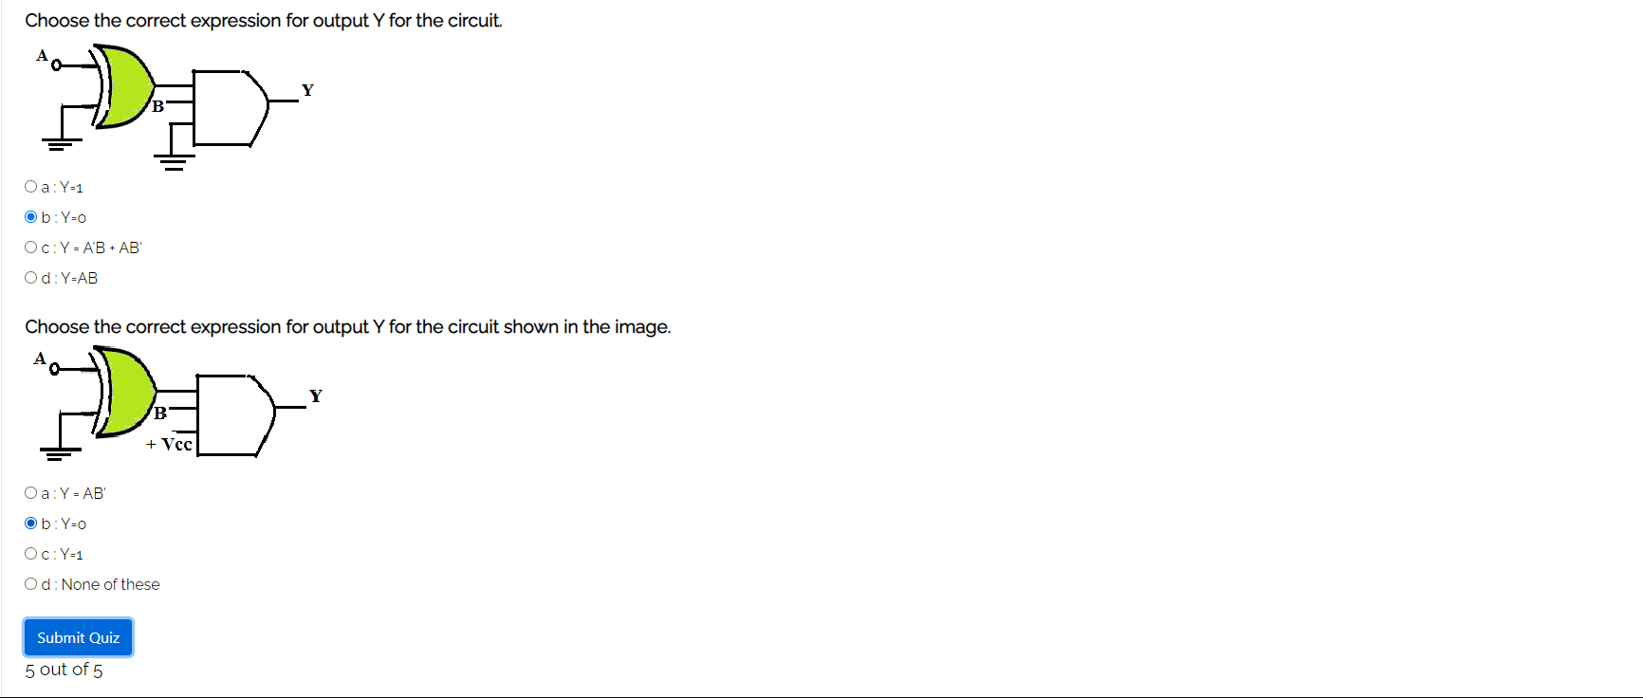

* **Simulation :-**

**Task:-** A two bit comparator circuit with inputs A2 A1 and B2 B1 is implemented to check for equality condition at input. Construct and verify the logic.

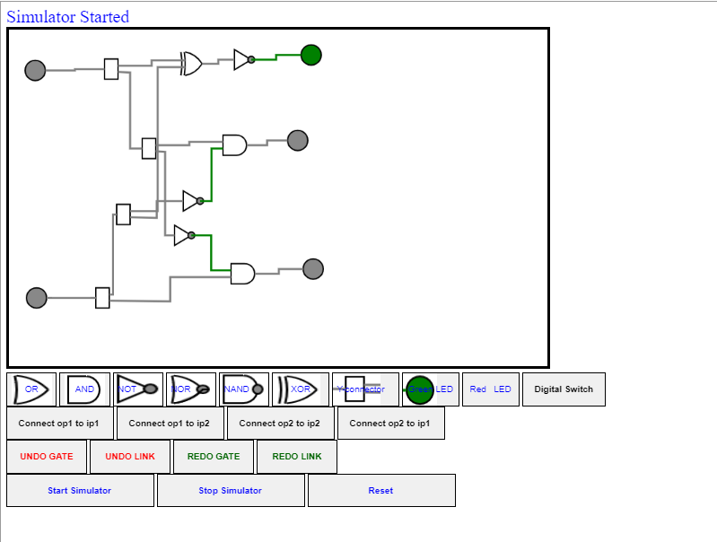

* 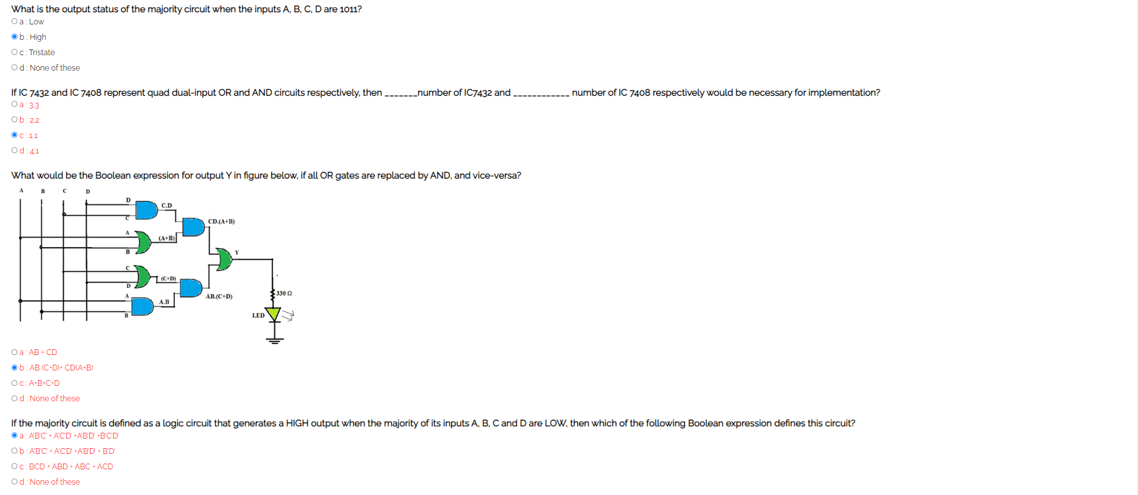**Post-test :-**

